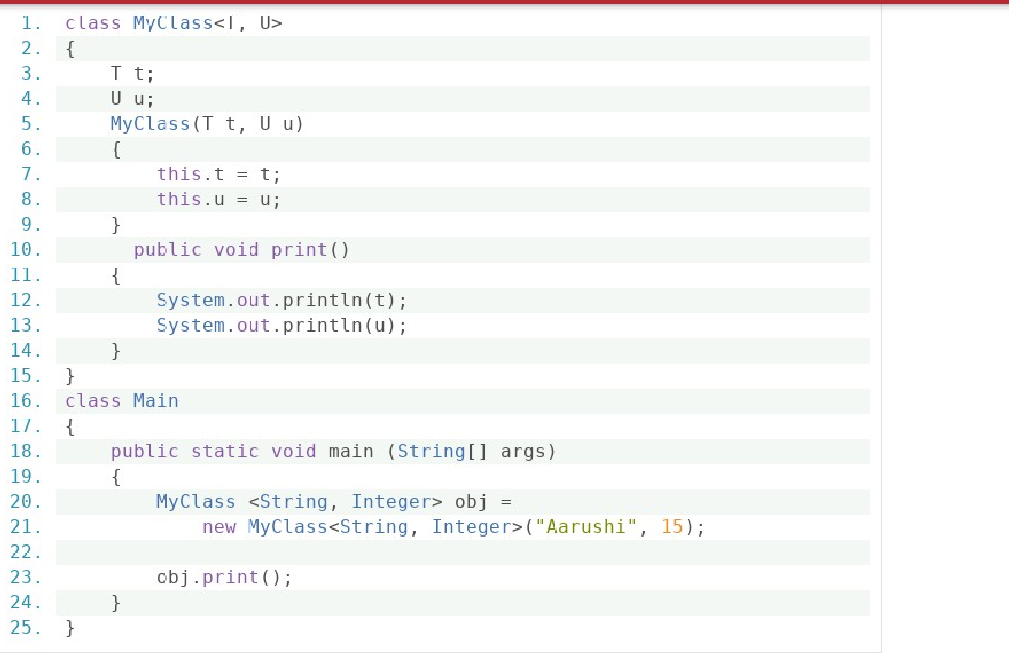

Output : Aarushi

15

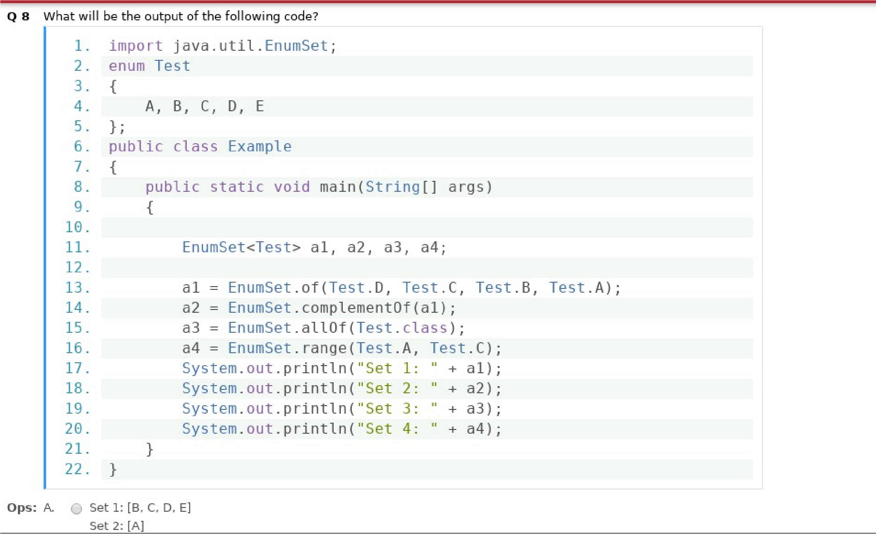Output : Set 1: [A, B, C, D]

Set 2: [E]

Set 3: [A, B, C, D, E]

Set 4: [A, B, C]

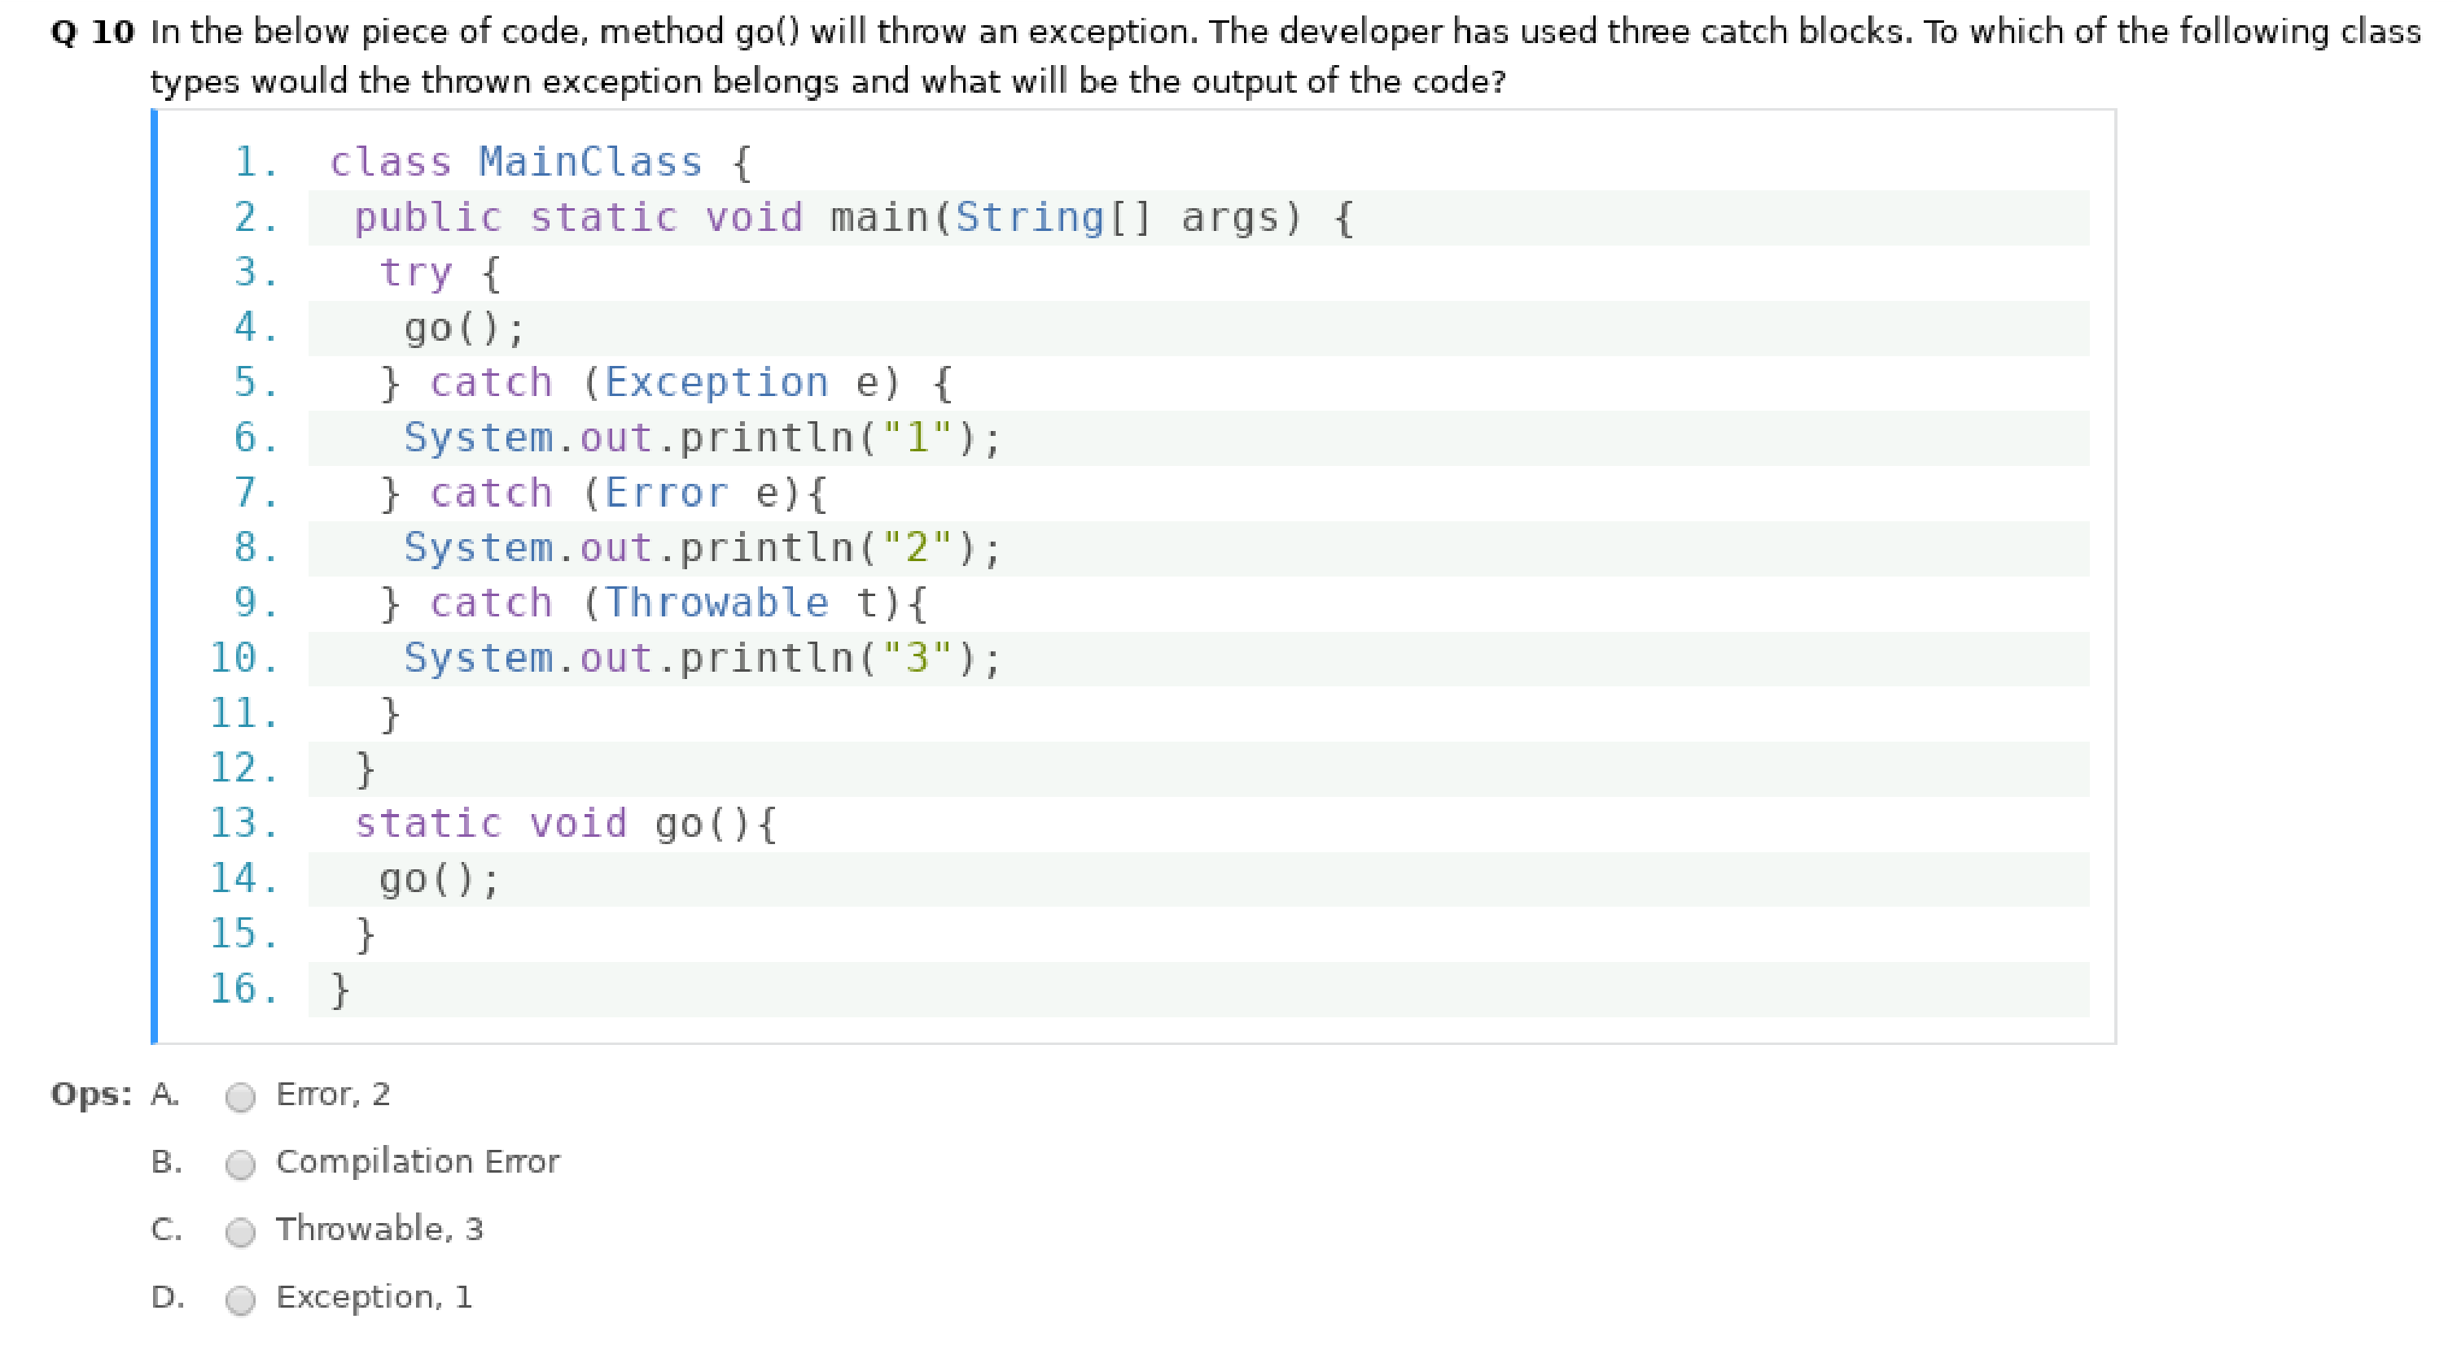

Answer : (A) Error , 2

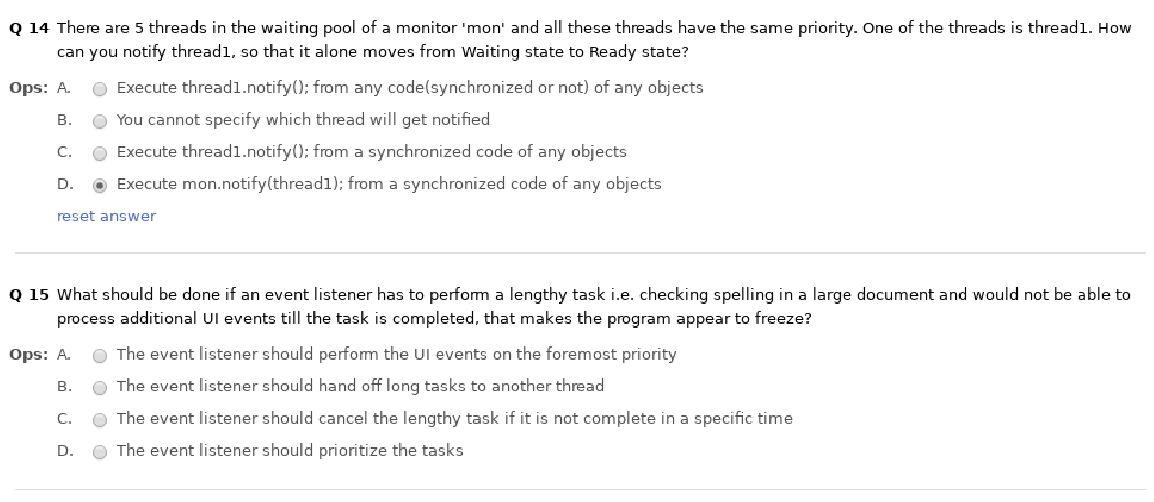

Answer No. 14 => (B) You can not specify which thread will get notified

Answer No. 15 => (B) The event listner should hand off long task to another thread

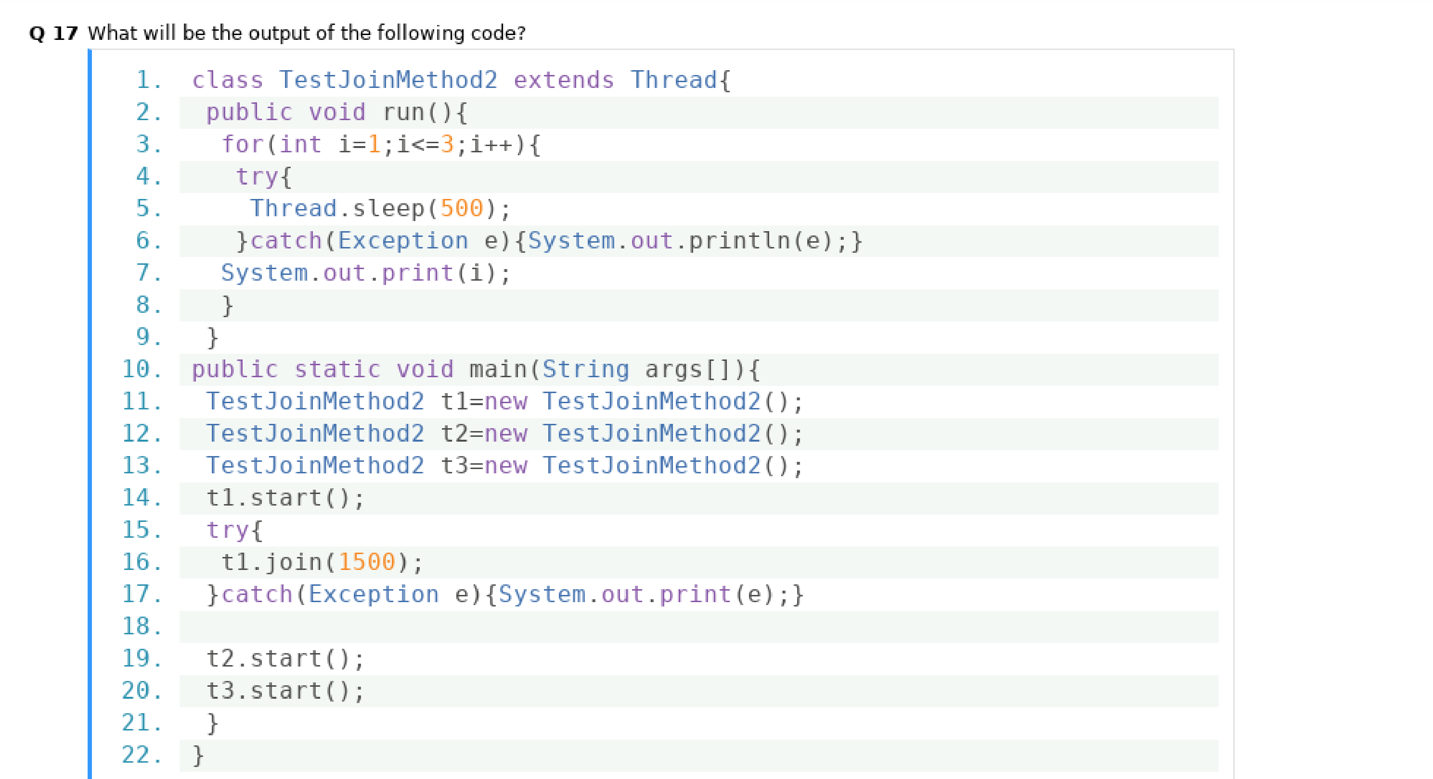

Output : 123112233

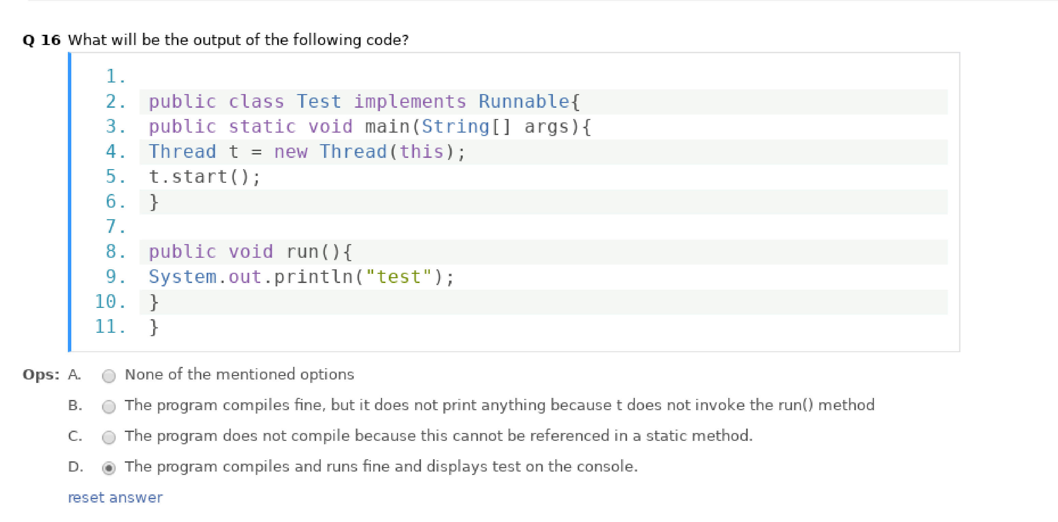

Answer No 16 => (C) The program does not compile because this can not be referenced in a static method.

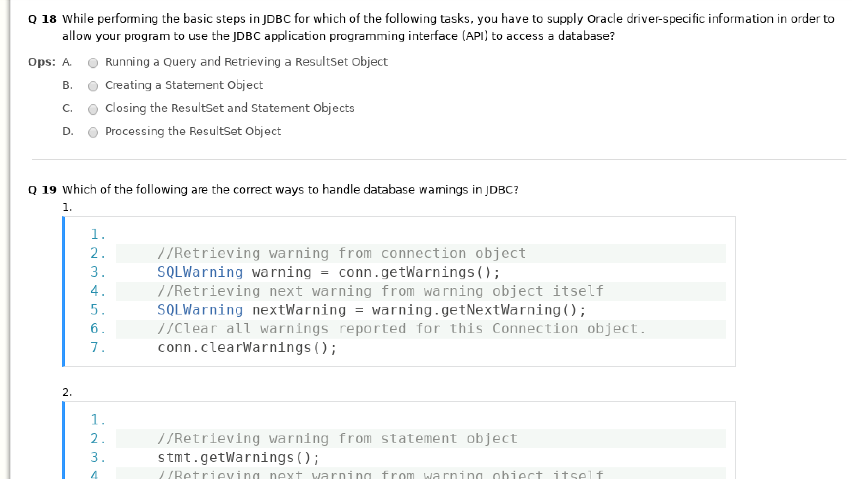

Answer No. 18 => (B) Creating a statement objects

Answer No. 19 =>

SQLWarning warning = stmt.getWarnings();

while (warning != null)

{

System.out.println("Message: " + warning.getMessage());

System.out.println("SQLState: " + warning.getSQLState());

System.out.println("Vendor error code: " + warning.getErrorCode());

warning = warning.getNextWarning();

}

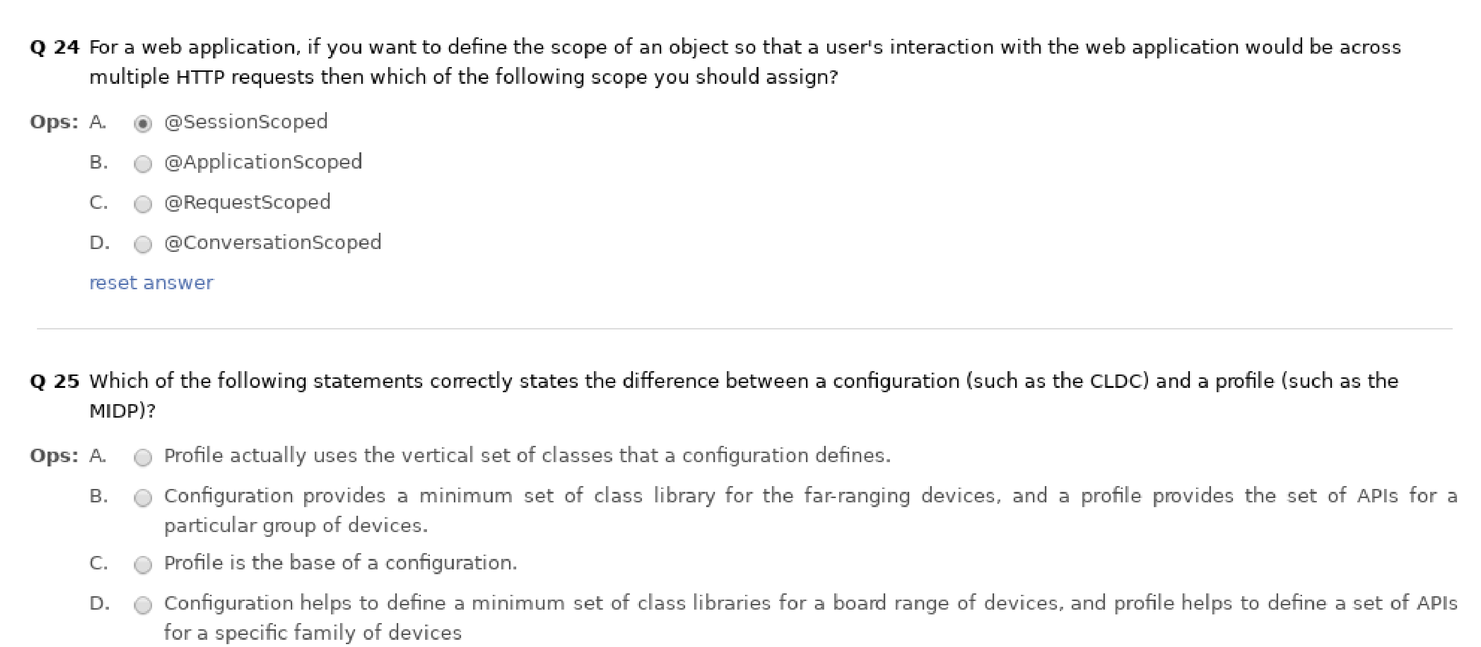

Answer No. 24 => (A) @SessionScoped

Answer No. 25 => (D) Configuration helps a define a minimum set of class libraries for a broad range of devices, and profile helps to define a set of APIs for a specific family of devices.

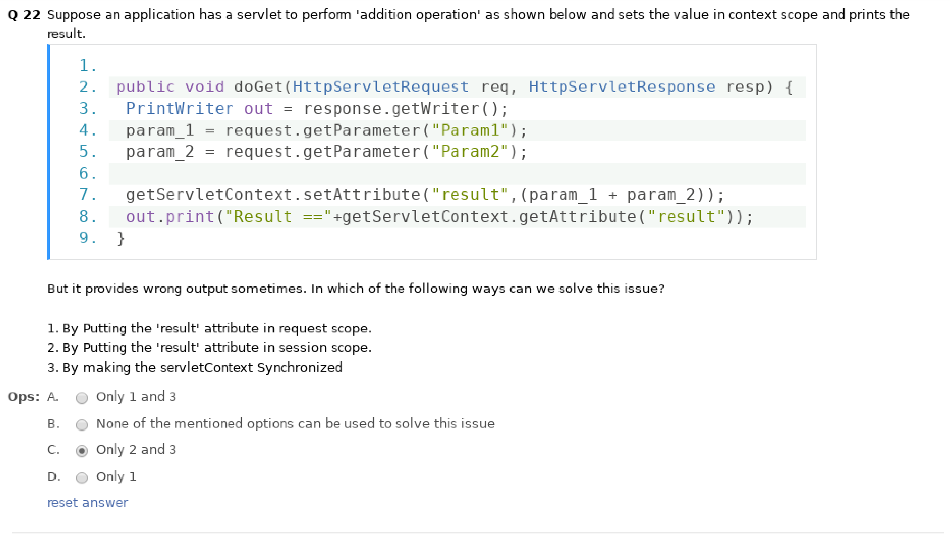

Answer No. 22 => (c) Only 2 and 3